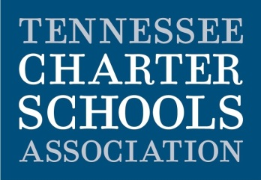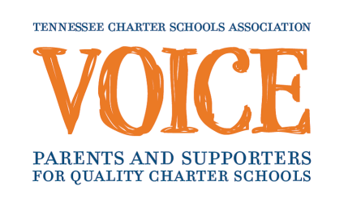

**Contact:**

Lauren Hayes

Tennessee Charter Schools Association

615-927-6780

lauren@tncharterschools.org

FOR IMMEDIATE RELEASE

November 28, 2012

**City-Wide Charter School Fair to be held on December 8th**

*All fall 2013 Nashville charter schools will be present to help MNPS families apply for enrollment*

Nashville, TN- The TCSA Voice, a program of the Tennessee Charter Schools Association, will host the first Nashville Charter School Information and Enrollment Fair on December 8th at the TSU Main Campus. Representatives from all charter schools operating in fall 2013, ranging from kindergarten through 12th will be available to present information and help families immediately apply for enrollment. The program, including remarks by Mayor Karl Dean at 11:15 a.m., will include student performances and charter school information sessions.

According to state data, Nashville area charter schools did an incredible job of increasing student performance this year. In both math and reading, the schools with the highest academic growth in Metro Nashville were public charter schools: STEM Prep in math and Nashville Prep in reading. Five charter middle schools were found among the top fifteen in terms of growth in math. In reading growth, five of the top seven middle schools were charter schools.

With five new schools opening, a total of eighteen charter schools will serve the Metro Nashville community in fall 2013. Charter schools are public, tuition-free schools of choice with open to all students. In exchange for the autonomy they receive, charter schools are held to higher accountability standards than traditional public schools. With this autonomy, many charter schools offer longer school days, personalized learning programs, or a specialized curriculum, such as college prep, classical, or STEM-focused. If more students apply than the number of seats available, a public lottery is held on January 19th to determine enrollment.

“We look forward to hosting this inaugural event for Metro Nashville families,” said TCSA Executive Director Matt Throckmorton, “where our primary goal is to help parents explore the charter school options and find a great fit for their child.”

**What:** Nashville Charter School Information and Enrollment Fair

**When:** Saturday, December 8th, 10 a.m. -­­ 2 p.m.

**Where:** TSU Main Campus, 3500 John A Merritt Blvd, Floyd Payne Campus Center, Kean Hall

Free parking will be provided for all attendees. A detailed agenda of day will be distributed to media closer to the event. For more information, contact Lauren Hayes or visit www.tncharterschools.org/enroll.

The Tennessee Charter Schools Association (TCSA), founded in 1998, serves quality public charter schools by educating communities, empowering supporters, and promoting legislation to create an educational landscape of excellent options for all students.

###